**Phase 1 “fping” I'd like to Teach the World to Ping**

**Layer Number 3 “the Network Layer”**

**Mitigate: Disable Ping Request**

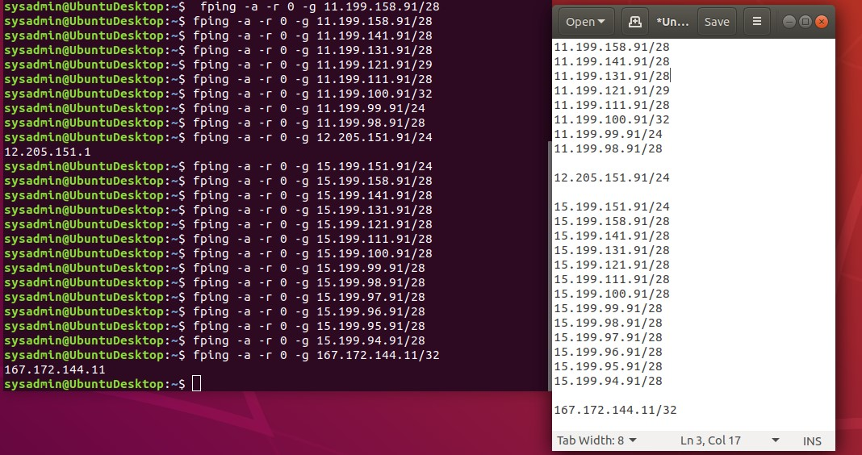

**Phase 2 “SYN SCAN” Some Syn for Nothin`**

**Layer Number 4 “the Transport Layer”**

**Mitigate: Setup Firewall Rules to Disable ICMP Packets**

**/**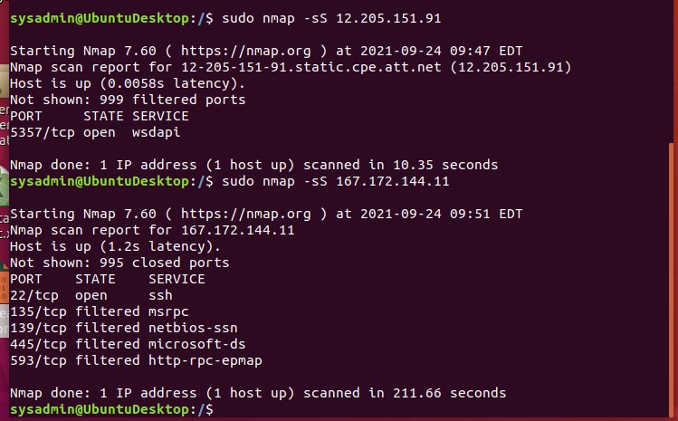

**Phase 3 “nslookup” I Feel a DNS Change Comin' On**

**Layer Number 7 “the Application Layer” Crop 1**

**Mitigate: Change User Name and Passwords, Run fping, Place DNS Filtering**

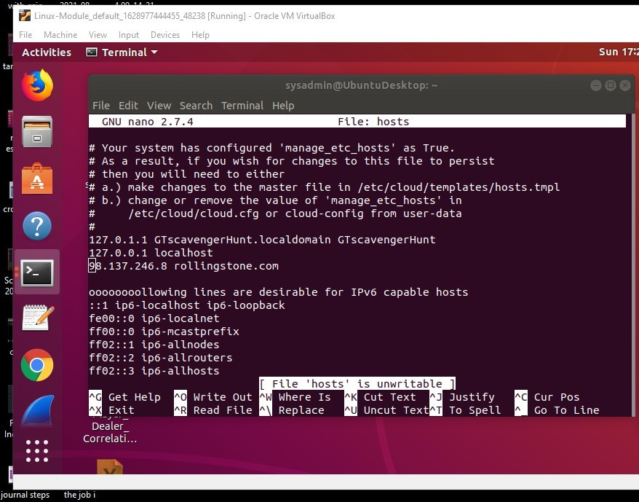

**Phase 3 “nslookup” I Feel a DNS Change Comin' On**

**Layer Number 7 “the Application Layer” Crop 2**

**Mitigate: Change User Name and Passwords, Run fping, Place DNS Filtering**

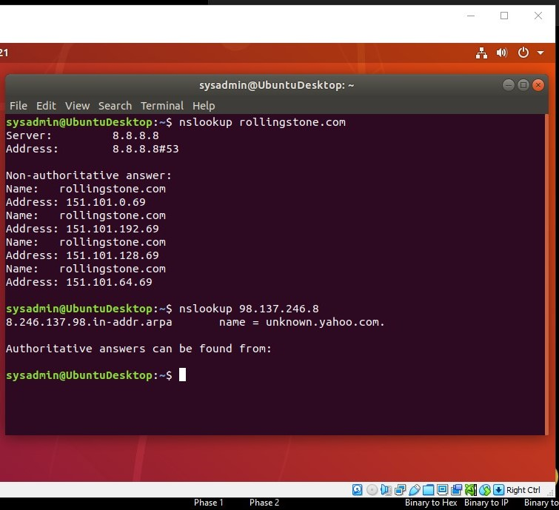

**Phase 4 “ARP” ShARP Dressed Man**

**Layer Number 2 “the Data Link Layer”**

**Mitigate: Run WireShark, Read All Arp, Block All Ping Request**

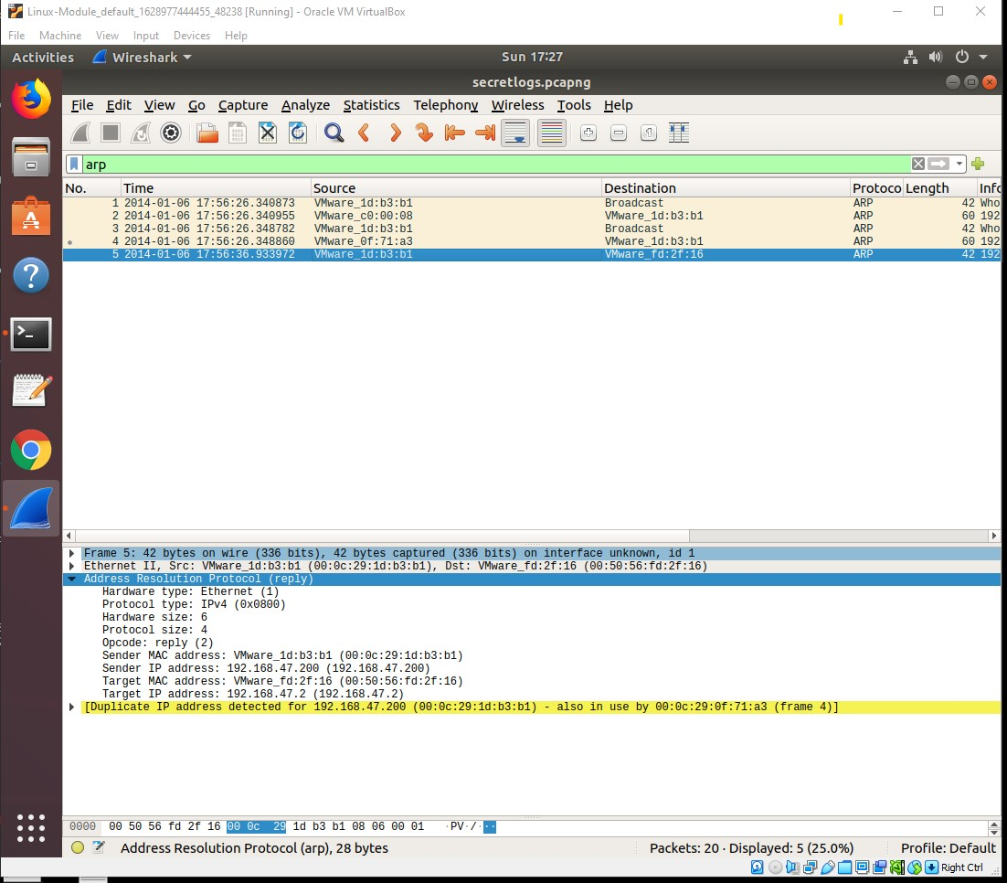

**Phase 4 “HTTP” ShARP Dressed Man**

**Layer Number 2 “the Data Link Layer”**

**Mitigate: Run WireShark, Read All HTTP, Block All Ping Request**

